Communication; Electromagnetic Waves

Types of Waves
Waves can be classified into three types:
- Mechanical waves
- Electromagnetic waves
- Matter waves
Mechanical Waves:
Propagation of disturbance through material medium due to the periodic motion of the particles of the medium about their mean position.
Electromagnetic waves:
Propagation of disturbance does not require material medium and travel through vacuum. Caused due to mutually perpendicular varying magnetic and electric field.
Matter waves:
Matter waves are the waves produced by tiny particles and electrons.
Electromagnetic waves:
When Charged particle vibrates, it produces an alternating electric and magnetic fields vibrating at right angles to each other which lead to the electromagnetic waves.
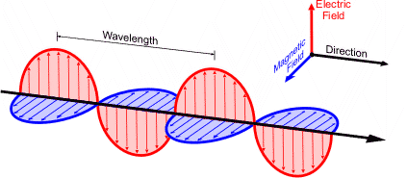

Properties of EM waves
- Electromagnetic waves contain both varying magnetic and electric field components perpendicular to each other and propagation of the wave.
- The electric Component is vertically polarized.
- EM waves are invisible and transverse waves.
- In vacuum the speed of EM waves is 3 x 10⁸ m/S.
- Exhibit phenomena like reflection, refraction, Interference, Diffraction and polarization.

Classification of Electromagnetic Communication Waves
Sl. No. | Name of the frequency range (Band) | Short Form | Frequency Range
1 | Very Low Frequency | VLF | 3 kHz to 30 kHz
2 | Low Frequency | LF | 30 kHz to 300 kHz
3 | Medium Frequency or Medium Wave | MF or MW | 300 kHz to 3 MHz
4 | High Frequency or Short Wave | HF or SW | 3 MHz to 30 MHz
5 | Very High Frequency | VHF | 30 MHz to 300 MHz
6 | Ultra High Frequency | UHF | 300 MHz to 3,000 MHz
7 | Super High Frequency or Micro Waves | SHF | 3 GHz to 30 GHz
8 | Extremely High Frequency | EHF | 30 GHz to 300 GHz

Propagation of Electromagnetic Waves:
Depending on the frequency, radio waves and micro waves travel in space in different ways. Depending on the behaviour of these waves w.r.t. the earth and the atmosphere. They are classified as:
- Ground wave propagation
- Space (or tropospheric) wave propagation
- Sky (or ionospheric) wave propagation
- Ground wave propagation:
- In ground wave propagation, the radio waves (AM) travel along the surface of the earth. These waves are called ground waves or surface waves.
- In fact, these waves are not confined to surface of the earth but are guided along the earth’s surface and they follow the curvature of the earth.
- The energy of the radio waves decreases as they travel over the surface of the earth due to the conductivity and permittivity of the earth’s surface.
- Attenuation increases with the increase in frequency.
- Therefore, the ground waves are limited to frequency of 1.5 MHz (1500 kHZ) or wavelength of 200 m.
2. Space wave propagation or Tropospheric wave propagation:
Space waves travel in (more or less) straight lines. But they depend on line-of-sight conditions. So, they are limited in their propagation by the curvature of the earth.
They propagate very much like electromagnetic waves in troposphere region.
Two Components of Space Waves
- Direct or Line of Sight Waves: These waves travel directly from the transmission antenna to the receivers antenna.
- Ground Reflected waves: These are reflected from the earth surface to thereceivers antenna.
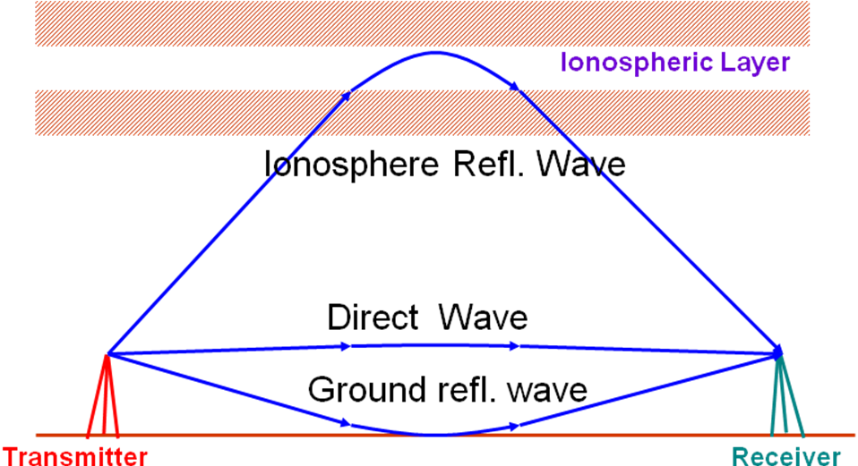

3.Sky wave propagation or Ionospheric wave propagation:
Sky waves are the AM radio waves which are received after being reflected from ionosphere. The propagation of radio wave signals from one point to another via reflection from ionosphere is known as sky wave propagation.
The UV and high energy radiations from the Sun are absorbed by the air molecules and they get ionised to form the ionised layer or electrons and ions. Ionosphere extends from 50 km to 320 km in the atmosphere above the earth’s surface.

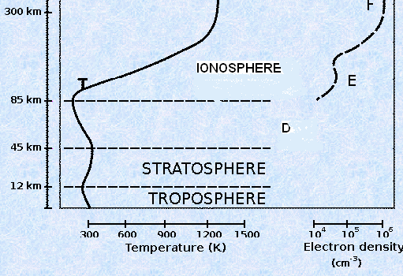
According to temperature and Electron density the Atmosphere
is divided into three regions
- Troposphere
(0-12 Km)
- Stratosphere
(12- 45 Km)
- Ionosphere
(45 – 320 Km)

IONOSPHERE
- It is named ionosphere, because it consists of ions and electrons created from neutral molecules and atoms by solar radiation.
- Ionosphere separates into four distinct layers:
1. D-layer (50-90 km) existing only during the day-time periods.
2. E-layer (90-130 km).
3. F-layer (130-300 km) which can be differentiated into F1 (150-200 km) and F2 (250-320) layers.

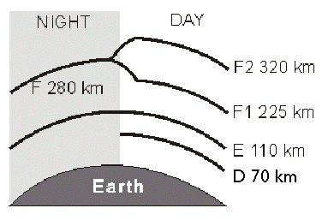
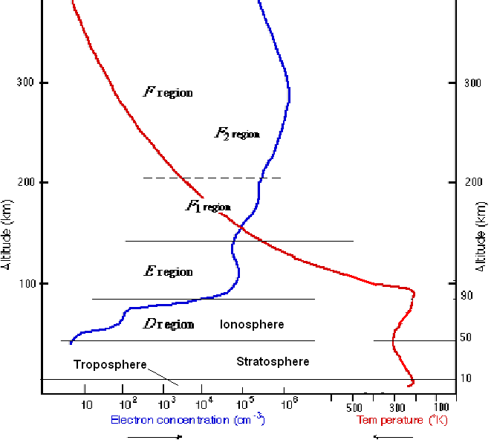

Sky wave propagation or Ionospheric wave propagation:
The sky wave propagation is a consequence of the total internal reflection of radio waves. Higher we go in the ionosphere, free electron density increases and refractive index decreases.
The oscillating electric field of electromagnetic wave (frequency ω) does not affect the velocity of the ions (negligible change because the EM wave field is weak) in the ionosphere but changes the velocity of the electrons
This changes the effective dielectric constant ε’ and hence the refractive index n’ as compared to the free space values ε₀ and n₀.
ε’ and n’ are related to ε₀ and n₀ as

n’ = √(ε’n₀)

or

n’ = n₀ [1 – (Ne2 / ε₀mω2)]½

where e is the electronic charge, m is the mass of the electron and N is the electron density in the ionosphere and ω=2πf.
It is clear that the refractive index of ionosphere n’ is less than its free space value n0. So, it acts as rarer medium. Therefore, for the angle of incidence above the critical angle, the electromagnetic waves undergo total internal reflection and reach the earth back.
Since n’ depends on ω and N, the waves of different frequencies will be reflected back from the different depths of ionosphere depending on electron density N in that region.
If the frequency ω is too high, then the electron density N may never be so high as to produce total internal reflection. This frequency is called ‘critical frequency’ (fc). If the maximum electron density of the ionosphere is Nmax per m3, then the critical frequency is given by:
fc ≈ 9(Nmax)½

Critical Frequency (fc):
It is the maximum frequency for a given ionospheric layer that can be returned down to the earth by that layer for a vertical incidence.
fc = 9(Nmax)½
Maximum Usable Frequency (MUF):
It is the limiting frequency for some specific angle of incidence other than the normal. For this case the critical frequency is higher and is given by
MUF =
cos θ
Critical Frequency
= 9(Nmax)½ sec θ = f_{c}sec θ
This is called ‘secant law’ and is very useful in making preliminary calculations for a specific MUF.
It is clear that the degree of bending depends upon i) angle of incidence, ii) Ion Density and iii) frequency of the incident radio waves
Skip Distance:
$D_{\text{Skip}}=2h\sqrt{\left(\frac{f^{2}}{f_{c}^{2}}−1\right)}$It is the shortest distance from a transmitter, measured along the surface of the earth, at which a sky wave of fixed frequency “f” (greater than fc) will be returned to earth.
h – Height of ionized layer Dskip depends on f and h

Virtual height:
The vertical distance of the point where actually the radio wave reflected in the ionosphere from the earth surface is called virual height.
Virtual height is greater than the Actual height.
CRITICAL ANGLE (θc)
The maximum vertical angle for which, the transmitted signal returns to the earth surface.
Critical angle θc depends upon the density of the Ionization and frequency of the signal
Ionospheric Layer
Lower Rays
Upper Ray
Actual Height
Virtual Height
T
Ground Surface
Skip Distance
θ_{c}

MODULATION:
Defnation: In this process audio signal is superimposed over a high frequency wave known as carrier wave. The resultant wave is known as modulated wave or radio wave and the process is known as modulation
OR
It is the process to change the characteristics (Amplitude, Frequency or Phase) of carrier wave in accordance with the intensity of the modulating signal is called modulation
Need for modulation:
The various factors responsible for the need of modulation are as given below.
1. Practical Antenna Length:
According to the theory to transmit a wave effectively, the length of the transmitting antenna should be approximately equal to one forth of the wavelength of the wave.
We know that velocity = frequency x wavelength
i.e. c = λf
Therefore λ = c/f
where c is the velocity of the electromagnetic wave i.e. c = 3 x10⁸ cm/s, f is the frequency of the audible sound. Its range is 20 Hz to 20 kHz.
Therefore λ = 3 x10⁸/20 x 103
= 15,000 meter = 15 km
The required length of the antenna = l = λ /4
Therefore l = 15/4 = 3.75 km
It is too long antenna. It is not practicable to have such a long antenna for transmission of audio signal directly into space. On the other hand, if a carrier wave of frequency 1000 kHz i.e. 106 Hz is used to transmit the signal, the length of the antenna becomes l = 3 x10⁸/4 x 106 = 75 m.
2. Operating range:
Energy of the wave is directly proportional to frequency , but audio signal has the frequency 20 Hz to 20 KHz, hence cannot traverse over a long distance
3. To achieve wireless communication over long distances.
4. Avoid mixing of Channels.
5. For Multiplexing of signals:
Multiplexing means transmission of two or more signals over the same channel same time. Different signals from different stations can be separated in the receiving station when the carrier frequencies for these signals are different.
6. Allows adjustments in the Band Width:
Signal to noise ratio in the receiver is the function of signal bandwidth. The bandwidth of modulated signal may vary. By the proper adjustment of the bandwidth of the modulated stage, signal to noise ratio can be improved.

Types of modulation
Sine wave (carrier) described by 3 parameters:
amplitude, frequency and phase.
v(t) = A sin (ωt + θ)
So we can have
1. Amplitude modulation (AM)
2. Frequency modulation (FM)
3. Phase modulation (PM)

1) Amplitude Modulation:
When the amplitude of the high frequency sinusoidal carrier wave is varied, in accordance with the modulating signal, keeping the frequency and the phase of the carrier wave constant, the process is known as amplitude modulation.
2) Frequency Modulation:
When the frequency of the carrier wave is varied in accordance with the modulating signal, keeping the amplitude and phase of the carrier wave constant.
3) Phase Modulation:
When the phase of the carrier carrier wave is varied in accordance with the modulating signal, keeping the amplitude and frequency of the carrier wave constant.

Amplitude Modulation:
Defination: When the amplitude of high frequency carrier wave is changed in accordance with the intensity of the modulating signal, the process is called amplitude modulation,but the frequency and phase of the carrier wave remains constant.
following figures, show how the amplitude of the carrier wave changes in accordance with their intensity of the signal without any change in the frequency of the carrier wave.
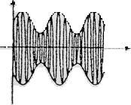
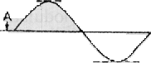
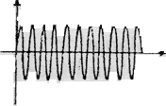

SIGNAL (i) CARRIER (ii) A.M.WAVE (iii)

Figure (i) shows the audio electrical signals.
Figure (ii) shows a carrier wave of constant amplitude and
Figure (iii) shows the amplitude of the modulated wave.
It is to be noted that, the amplitude of both positive and negative half cycles of carrier wave are changed in accordance with the signal. If the signal is increased in positive sense, the amplitude of the carrier wave also increases and vice versa.

Analysis of Amplitude Modulated Wave
$v_{m}=V_{m}\text{sin}ω_{m}t\text{ -------- }(1)$Let the instantaneous voltage of the modulating signal be
$v_{c}=V_{c}\text{sin}ω_{c}t\text{ ------- }(2)$Where Vm is the amplitude of the modulating signal and wm is the modulating frequency

Let the instantaneous voltage of the carrier signal be
Where Vc is the amplitude of the carrier signal and wc is the carrier frequency
When the amplitude of the (Vc) carrier signal varies in proportion to the instantaneous value of (vm) of the modulating signal then the amplitude modulation is attained
$\begin{aligned}A=V_{c}+v_{m} \\ V_{c}+V_{m}\text{sin}w_{m}t \\ V_{c}\left(1+\frac{V_{m}}{V_{c}}\text{sin}w_{m}t\right)=V_{c}\left(1+m_{a}\text{sin}w_{m}t\right)\text{ ------ }(3) \\ \begin{aligned}\left[{\text{Where m}}_{a}\text{ is called the modulation index} | \right] \\ \end{aligned} \\ \end{aligned}$
If A is the amplitude of the modulated wave, then we have

$v_{\text{AM}}=A\text{sin}w_{c}t\text{ -------- }(4)$As the frequency of the carrier wave is unaltered the instantaneous voltage of the resulting amplitude wave is given by

Substituting the value of A from eq. (3) in eq. (4) we have

$\begin{aligned}v_{\text{AM}}=V_{c}(1+m_{a}\text{sin}w_{m}t)\text{sin}w_{c}t \\ v_{\text{AM}}=V_{c}\text{sin}w_{c}t+V_{c}m_{a}\text{sin}w_{m}t\text{sin}w_{c}t \\ v_{\text{AM}}=V_{c}\text{sin}w_{c}t+\frac{m_{a}V_{c}}{2}\text{cos}(w_{c}−w_{m})t−\frac{m_{a}V_{c}}{2}\text{cos}(w_{c}+w_{m})t \\ \text{ Unmodulated Lowerside Upperside} \\ \text{ carrier Band Band} \\ \\ ∵\text{2sinAsinB}=\text{cos}(\text{A-B})\text{ - cos}(A+B)\end{aligned}$

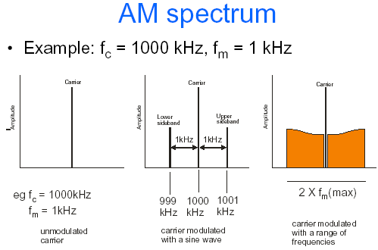
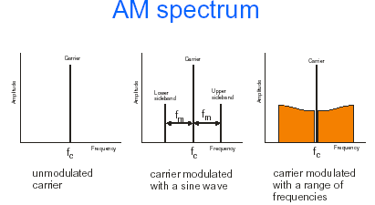

Modulation Factor or Modulation Index (m) :
We know that in amplitude modulation, the amplitude of the carrier wave is varied in accordance with the variation in the amplitude of the modulated signal. To what extent the amplitude of the carrier wave is changed by the signal is given by the factor known as modulation factor or modulation index (m).
It depends upon the relative amplitude of the carrier wave and the modulated wave at any instant during the process of modulation.
The ratio of amplitude of the modulated signal (V_{m}) to the amplitude of the carrier signal (V_{c}) is called the modulation factor. It is denoted by (m).
$m=\frac{V_{m}}{V_{c}}\text{ ------ }(1)$

$\text{Depth of modulation}=\frac{V_{m}}{V_{c}}×\text{100}$The value of m lies between 0 and 1. It can be expressed as a percentage and it is then called the depth of modulation.

From the equation (1) it is clear that, the modulation factor depends upon the amplitude of the carrier as well as modulated signal wave
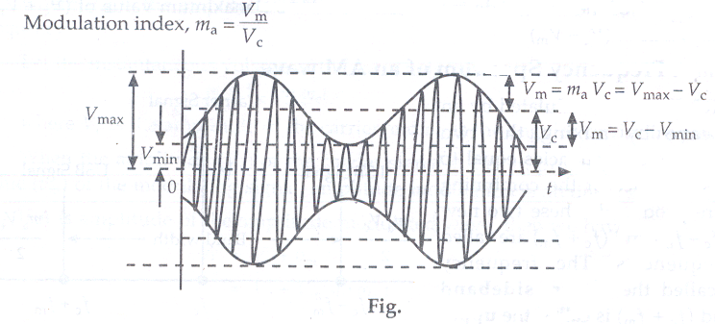
Expression for Modulation Index interms of Vmax and Vmin

The top envelope of the AM wave is shown in the above figure is given by
A=Vc+Vm sinwmt

Similarly the bottom envelope is given by
A= -(Vc+Vmsinwmt), From the figure we have,
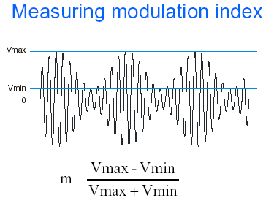
$\begin{aligned}V_{m}=V_{\text{max}}−V_{c} \\ \text{Therefore }V_{\text{max}}=V_{c}+V_{m}\text{ ------ }(1) \\ \text{and also }V_{\text{min}}=V_{c}−V_{m}\text{ ------ }(2) \\ \text{Adding and substracting one from other, we have} \\ V_{c}=\frac{V_{\text{max}}+V_{\text{min}}}{2}\text{ ------- }(3) \\ V_{m}=\frac{V_{\text{max}}−V_{\text{min}}}{2}\text{ ------- }(4) \\ \text{Therefore modulation factor }m=\frac{V_{\text{max}}−V_{\text{min}}}{V_{\text{max}}+V_{\text{min}}}\end{aligned}$

Amplitude modulated waves with various degrees of Modulation
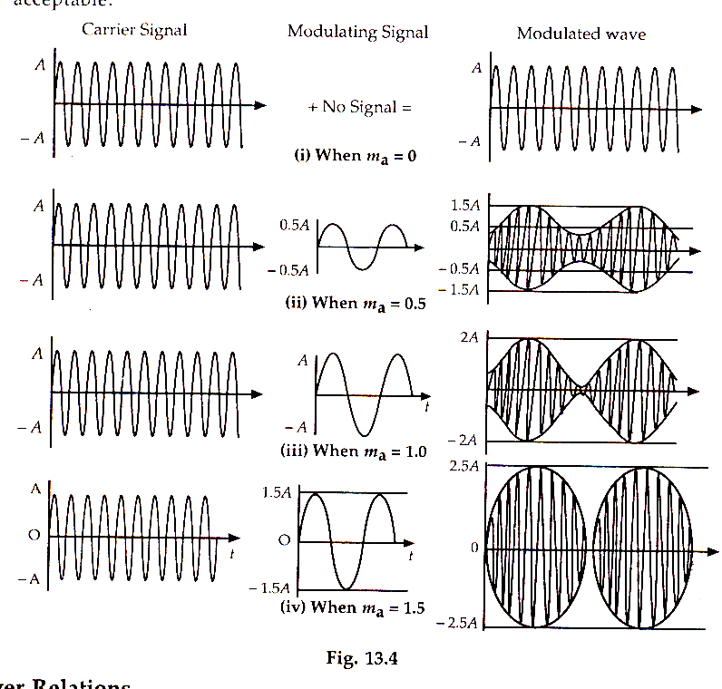

(i) Let ma = 0, it means that no amplitude modulation takes place
(ii) Let ma = 0.5,The amplitude of the modulating signal is half that of carrier signal
amplitude i.e. ma = Vm/Vc = 0.5 or 50%
(iii) Let ma = 1,The amplitude of the modulating signal is equal to that of carrier
signal amplitude i.e. ma = Vm/Vc = 1 or 100%
(iv) Let ma = 1.5, This is the case of over modulation. Thus any greater depth of
modulation utters distortion of the envelope and loss of information. The
amplitude of the modulating signal is one and half times that of carrier signal
amplitude i.e. ma = Vm/Vc = 1.5 or 150%. Thus large value of ma will produce
poor signal to noise ratio. Normally its value lies between 0.3 and 0.4.

Varying Modulation Index:

Importance of Modulation Factor:

- The modulation factor plays an important role during modulation process.
- It determines the strength and quality of the transmitter signal.
- In an amplitude-modulated wave, the signal is contained in the variation of he carrier amplitude.
- When the carrier is modulated to a smaller degree i.e. when m <<1, the amount of carrier amplitude variation is also small. Now the audio signal transmitted becomes very weak.
- As the degree of modulation is increased, the audio signal becomes stronger and clearer.
- But if m > 1 i.e. if the carrier wave is over modulated, the distortion occurs during the transmission
Due to over modulation i.e. if m > 1, the followings are some of the disadvantages.
1. In the gap portion, where there is no power transmitted to the antenna, the oscillator (transmitter) becomes unstable.
2. There will be instability in carrier frequency and voltage due to portion gap portion.
3. The quality of transmission is poor.
4. Sudden change in the output voltage at the gap portion produces noise in the transmission signal.
5. Since there are large numbers of sidebands, there will be interference with neighboring stations.
Hence from the above discussion we conclude that modulation index (m) is an important consideration in amplitude modulation and that its value should always lies between 0 and 1.

